**LOGISTIC RIGRESSION ASSIGNMENT**

**Que 1: -**

**Business Problem** = ﻿Prepare a prediction model for probability of extra marital affair.

* **Name of the File: -** Affairs.csv
* **Size of the File: -** 25 KB
* **Data: -** 601 Observation, 18 Variable

**Exploratory data Analysis** =

* **Outliers: -**  outliers are not presents.
* **Missing Value: -** Data don’t have Missing Values
* **Normality: -** Data are not normal
* **Output:** - Continues

1. **﻿**Converting numerical values of output column into Binary (0 and 1).
2. Measuring Percentage of non-affairs and affairs in output columns

**Affairs** - 25%

**Non Affairs** – 85 %

**Model Building on Train Data =**

* **Summary: -**

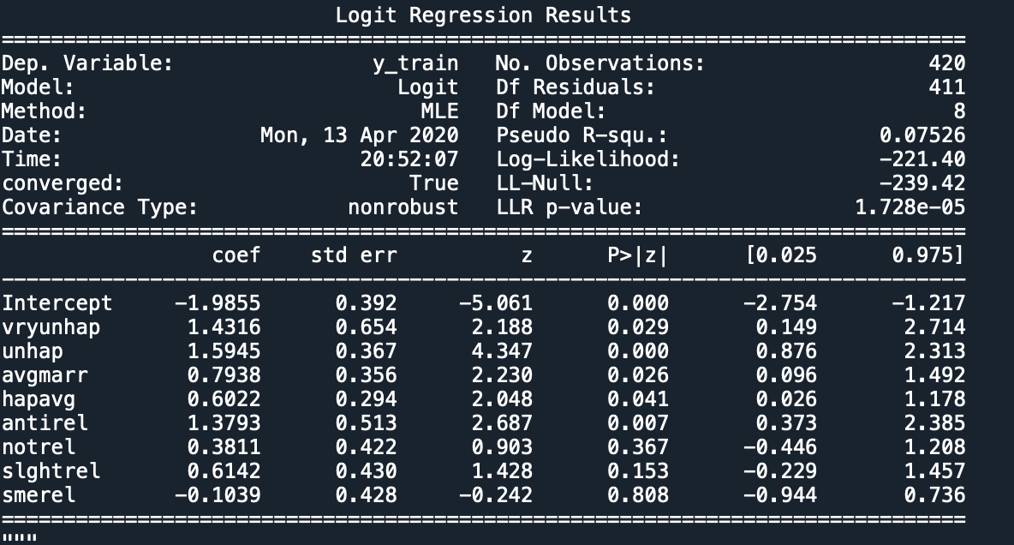

* **AIC: -** 461
* **﻿Accuracy :-** 79%
* **﻿Sensitivity :-** 98%
* **﻿Specificity: -** 14%
* **No observation: -** 420
* **﻿Df Residuals:** - 411

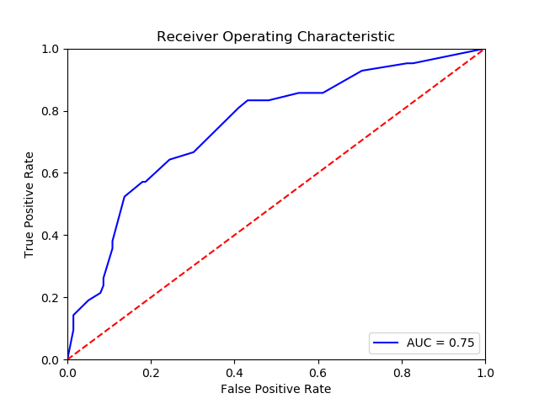**Roc Curve**: -

**Roc Curve**: - 75%

**Python code file**: - Affairs Assig-M9.py

**Packages used: -**

* ﻿pandas
* numpy
* scipy.stats
* matplotlib.pylab
* pylab
* statsmodels.formula.api
* seaborn as sns
* ﻿sklearn.model_selection import train_test_split
* ﻿statsmodels.api